|  |  |
| --- | --- |
| **Duration: 90 minutes**  **Instructions:**   * **Please write your answers on blank pages and not on the test pages.** * **Please write your name at the header of each page.** |  |

**Part 1: Test Cases – 50 points**

**Please write Test Cases for the following requirements.**

# Requirements

* 1. BOLT developed a responsive HTML standalone minisite for the WFG agents to use for the purpose of collecting data about a potential BOLT lead. The minisite should fit all Desktop, tablet and mobile view modes (all browsers and mobile OSs).
  2. WFG agent flow

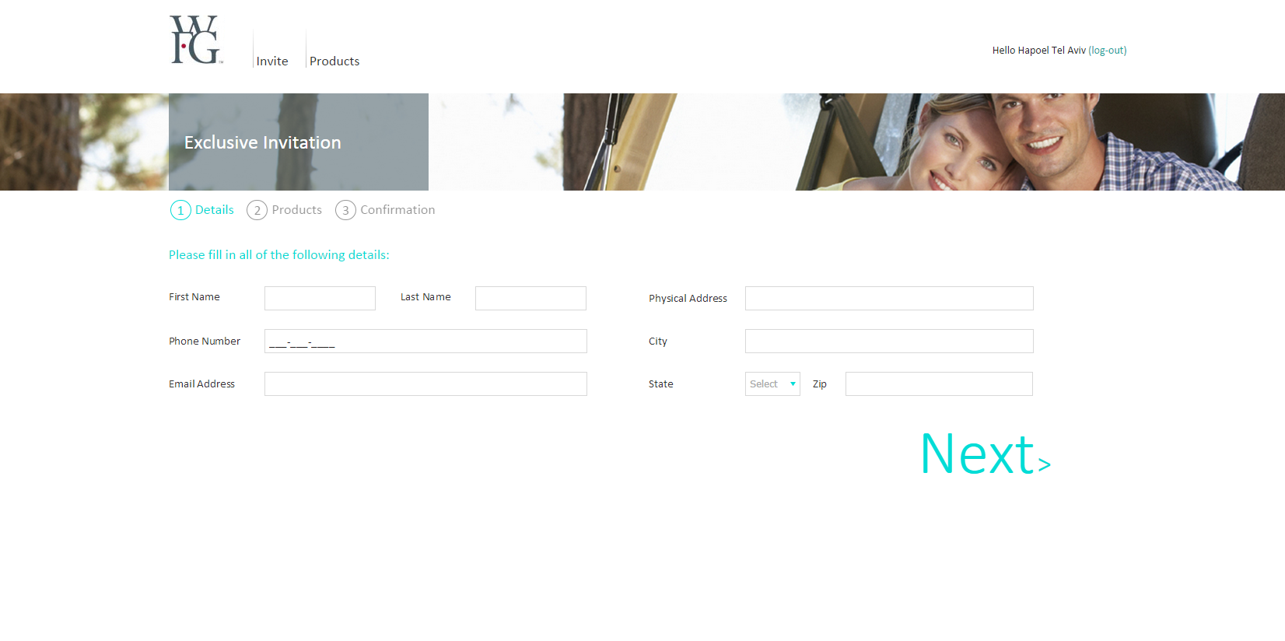

* 1. Details page Form validation

|  |  |  |  |
| --- | --- | --- | --- |
| Field name in minisite | Invalid characters/Expected format | Validation message  *Server side validation | Maximum length *Client side validation |
| First Name | Invalid characters: < > & " % ; : !) ( " + | ~ * ? ^ # $ 0-9 / \ @ - _ = + { } [ ] ' , .  Expected format: All letters | **“First Name must include only letters.”** | 16 Chars |
| Last Name | Invalid characters: < > & " % ; : !) ( " + | ~ * ? ^ # $ 0-9 / \ @ - _ = + { } [ ] ' , .  Expected format: All letters | **“Last Name must include only letters.”** | 20 Chars |
| Phone Number | Expected format: All numbers |  | 10 Numbers |
| Email | Expected format: ^([a-zA-Z0-9_\-\.]+)@((\[[0-9]{1,3}\.[0-9]{1,3}\.[0-9]{1,3}\.)|(([a-zA-Z0-9\-]+\.)+))([a-zA-Z]{2,4}|[0-9]{1,3})(\]?)$ | **“Please make sure the email you entered is formatted correctly (e.g.,** [xxxx@xxx.com)](mailto:xxxx@xxx.com))**.”** | 50 Chars |
| Physical Address | N/A |  | 50 Chars |
| City | N/A |  | 30 Chars |
| State | N/A |  | 20 Chars |
| Zip | Expected format: All numbers  Not mandatory |  | 1. numbers |

* + 1. If any of the above mandatory fields isn’t filled with user input, when clicking to move to the next page the following validation will appear:

Validation message: “Please complete all fields.” (Client side)

* + 1. When any mandatory field wasn’t filled, the validation will color the text field red. (Client side)
    2. Validation messages - the messages order:

“Please complete all fields.” Which will color all of the empty fields’ red.

Fields’ format validation messages. If all fields have been completed, the format validation will be start.

The validations mechanism will present one message at a time.

* 1. Address suggestion page

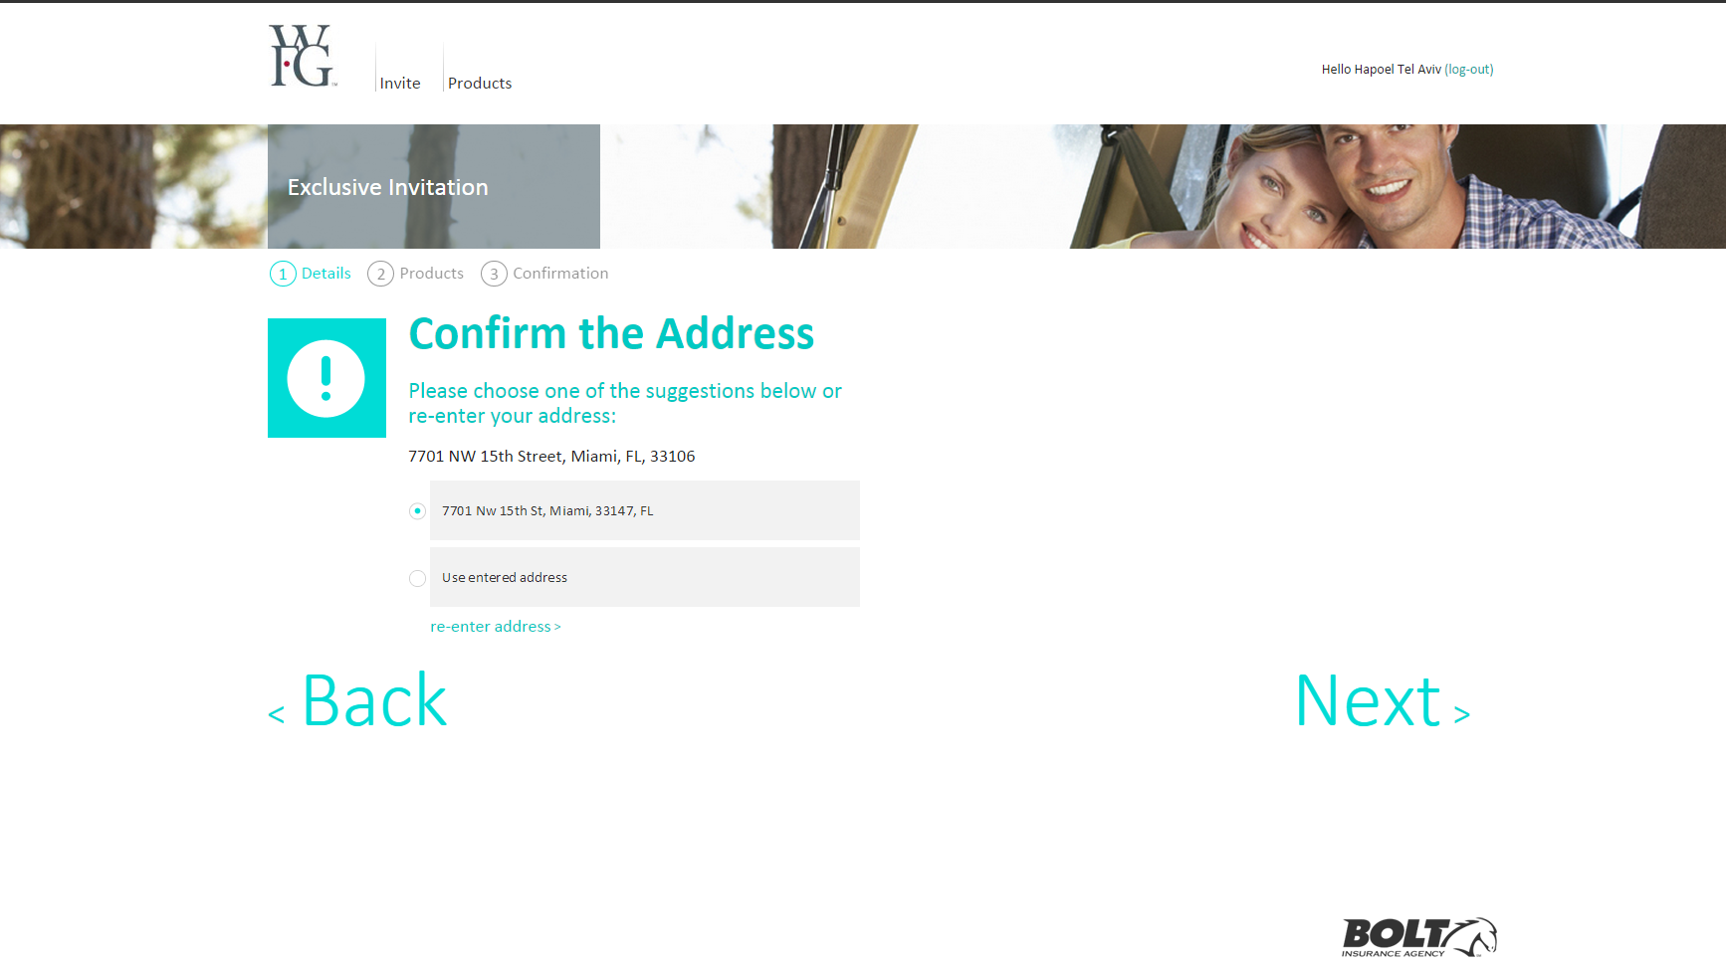

Each address put in the minisite will be confirmed via an external address validation service.

If the address was fully validated, the address suggestion page will not appear.

The address suggestion page will show up to 3 suggested addresses.

If zip code was put in, the last suggested option will be “Use entered address”

If a more accurate address is provided by the service, the following message will appear:

Upper title: “Confirm the Address”

Below: concatenate of the address data from the details page Physical address+“,”City+“,”State+“,”Zip*

*If zip has a value

Below it: “Please choose one of the suggestions below or re-enter the address”

If no address is provided by the service, the following message will appear:

Upper title: “No match found”

Below: concatenate of the address data from the details page Physical address+“,”City+“,”State+“,”Zip*

*If zip has a value

Below it: “Please verify the address”

The “re-enter address >“ button should be placed dynamically after the last radio button option, if there’s one, two or three suggestion options.

And if no suggestion is available, and zipcode wasn’t entered-then the button should appear instead of the button “Next >”.

If user decided to send an inaccurate address, then when entering the consumer site-the address may be modified based on the address service in the platform.

**Part 2 – Testing methodologies – 20 Points**

**Please answer the following questions:**

1. Describe how would you test a system with thousands of test cases, given that you don't have enough time to test them all?
2. Define the difference between Regression tests and Sanity tests
3. Explain bug life cycle.
4. What is the difference between severity and priority?
   1. Give an example of a high severity and low priority bug.
   2. Give an example of a low severity and high priority bug.
5. Suppose you find a critical bug, how would you make sure that the same bug is not introduced again?

**Part 3: SQL – 30 Points**

**Please answer the questions using the mock DB’s with the following credentials:**

SQL server: Oleg-dt

Database: QaTest

User: qa

Password: qa

1. Based on the below database diagram Write SQL queries that return the following:
   1. Which one of the titles of the movies were released in **2009**?
   2. Which is the longest movie based on the number of minutes.
   3. Which are the movies that released before or equal **2000**.

**Table: Movies**

|  |  |  |  |  |
| --- | --- | --- | --- | --- |
| **Id** | **Title** | **Director** | **Year** | **Length_minutes** |
| 1 | Toy Story | John Lasseter | 1995 | 81 |
| 2 | A Bug's Life | John Lasseter | 1998 | 95 |
| 3 | Toy Story 2 | John Lasseter | 1999 | 93 |
| 4 | Monsters, Inc. | Pete Docter | 2001 | 92 |
| 5 | Finding Nemo | Andrew Stanton | 2003 | 107 |
| 6 | The Incredibles | Brad Bird | 2004 | 116 |
| 7 | Cars | John Lasseter | 2006 | 117 |
| 8 | Ratatouille | Brad Bird | 2007 | 115 |
| 9 | WALL-E | Andrew Stanton | 2008 | 104 |
| 10 | Up | Pete Docter | 2009 | 101 |
| 11 | Toy Story 3 | Lee Unkrich | 2010 | 103 |
| 12 | Cars 2 | John Lasseter | 2011 | 120 |

1. Based on the below database diagram Write SQL queries that return the following:
   1. All the account details that belong to agent Jane Doe in state is NY.
   2. The number of Policies per Insurance company that have a premium greater than 0?

The results should be in the following format:

|  |  |
| --- | --- |
| **Insurance Company** | **Number Of Policies** |

* 1. The average Premium for the Black Mountain Agency (AgencyName = 'Black Mountain Agency').

